Using a Master Prompt to Create Consistent AI-Generated Course Images
Jessica Dalton-Carriger

Image example for ANTH1430: Into to Prehistoric Archaeology
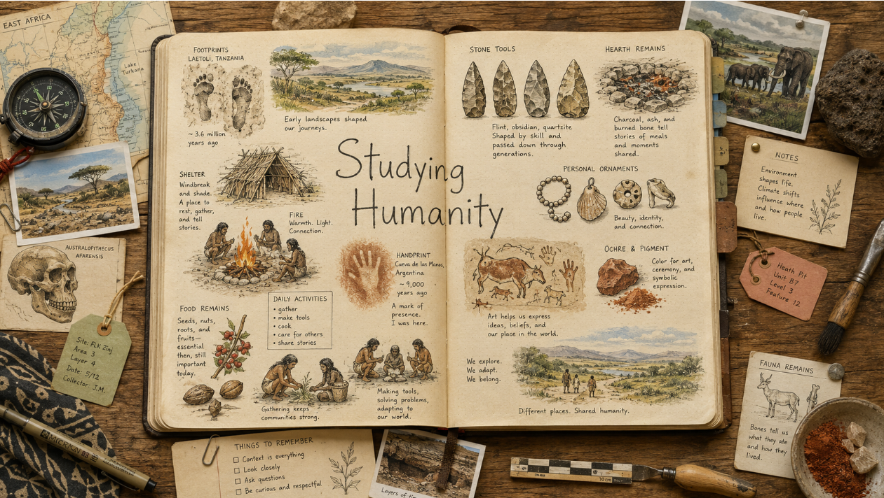

Image example for SOCI 1010: Into to Sociology
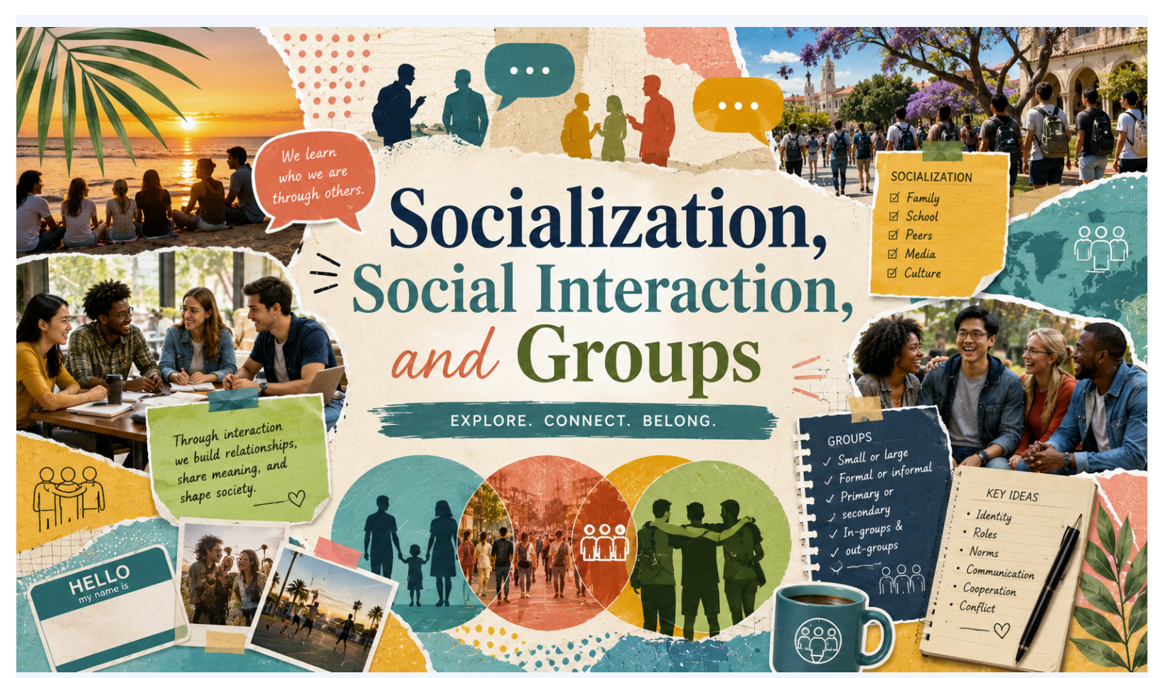

Image example for ANTH1230: Into to Cultural Anthropology
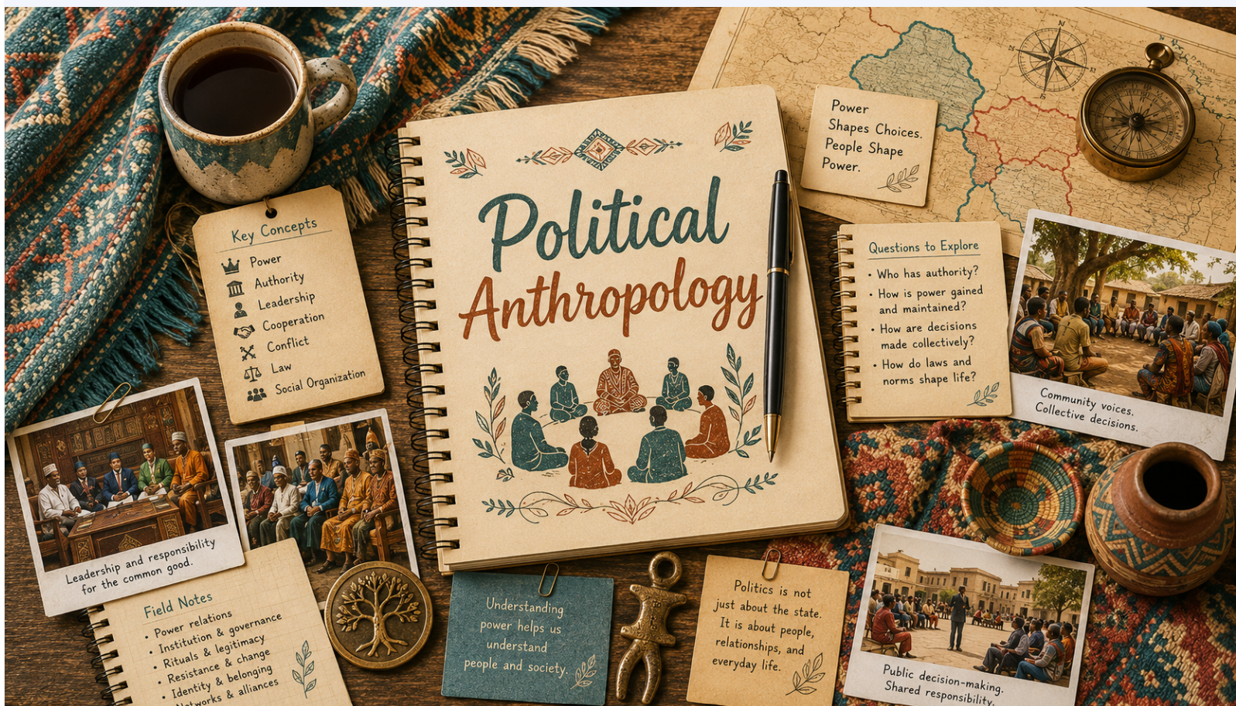

Image example for ANTH1130: Into to Biological/Physical Anthropology
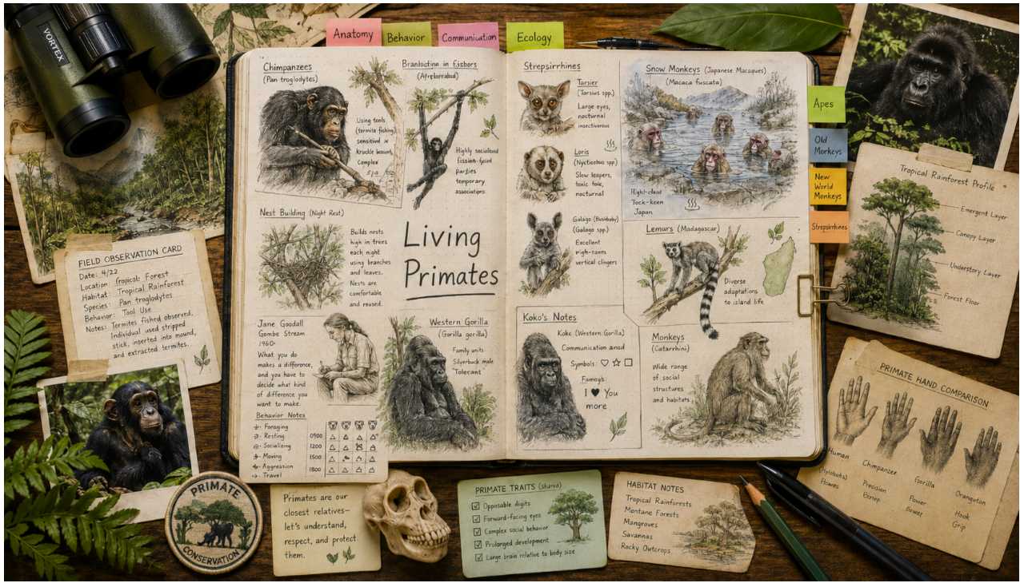

Image example for PHED 1585: Yoga Basics
