TBR AI FELLOWS · PROJECT PROPOSAL
Virtual Labs, Built with AI
Using generative AI to build hands-on lab simulators and deliver them to students through Brightspace — and turning it into a method any instructor can follow.
My fellowship project is to use generative AI to build interactive virtual labs and put them in front of students through Brightspace, so they get hands-on practice even when the real equipment is scarce — and so any instructor can do the same.
THE PROBLEM
Students need hands-on practice. The real equipment is scarce.
Across the TBR system — community colleges and TCATs alike — the most career-relevant skills are the ones that need a physical thing to practice on: a sound board, shop equipment, a clinical scenario, lab apparatus. There is rarely enough of it for every student to practice, fail safely, and try again before it counts.
WHAT I'LL BUILD
Use AI to build the lab, and let Brightspace grade it.
The plan is not one tool — it is a repeatable way to build them. I describe what students need to practice, and a generative AI tool does most of the building. The simulator is packaged as a SCORM module that loads into Brightspace and reports scores to the gradebook on its own. Practice that used to be limited by equipment access becomes something every student can do on their own time, and it counts toward their grade.
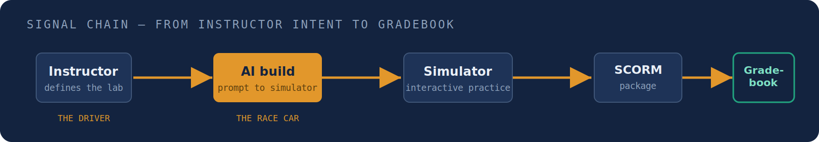
The AI is the race car. The instructor is still the driver — steering the content, the pedagogy, and what “correct” means.
PROOF I CAN DELIVER
I've already built a working example: a virtual mixing console.
To show the approach works, I built an audio-console simulator for our Sound and Light Technology program, where time on the physical board is limited. I described what students needed to practice, tested it against how the real board behaves, and fixed it until it was right. I am not a developer and did not buy any courseware — the AI did the building while I stayed in control of the content and what counts as correct. It is the template for everything else.
WHAT THE FELLOWSHIP DELIVERS
Turn this into something any instructor can use.
The console is one example. Through the fellowship I would take the same method and make it repeatable, so it works for almost any program that needs hands-on practice but is short on equipment or lab time. It only takes a generative AI tool and the Brightspace SCORM setup every TBR campus already has, so any instructor at any community college or TCAT could follow it — and finished labs can be shared through the TBR AI Exchange for other campuses to use. Programs that could benefit include:
- Nursing & Allied Health — clinical and patient scenarios
- Trades & TCAT programs — equipment and safety simulation
- Sciences — lab procedures and experiments
- Mathematics — guided problem walkthroughs
- Business — branching case studies
- IT & Data Center — hands-on technical environments
WHAT I'LL DO AS A FELLOW
Exactly what the program is asking for.
- Build and run it. Develop the virtual-lab method and use it in a real class during the fellowship.
- Use AI responsibly. Check the AI's work, build for accessibility, and stay responsible for accuracy and grading.
- Make it repeatable. Write it up so other instructors can follow the same steps, and share it on the AI Exchange.
- Help students and budgets. More hands-on practice in career programs, at no software cost to students.
Dave Trent
Assistant Professor of Computer Science · Northeast State Community College · 24 years as a healthcare CIO before the classroom

